http://corona-virusapps.com/#

~~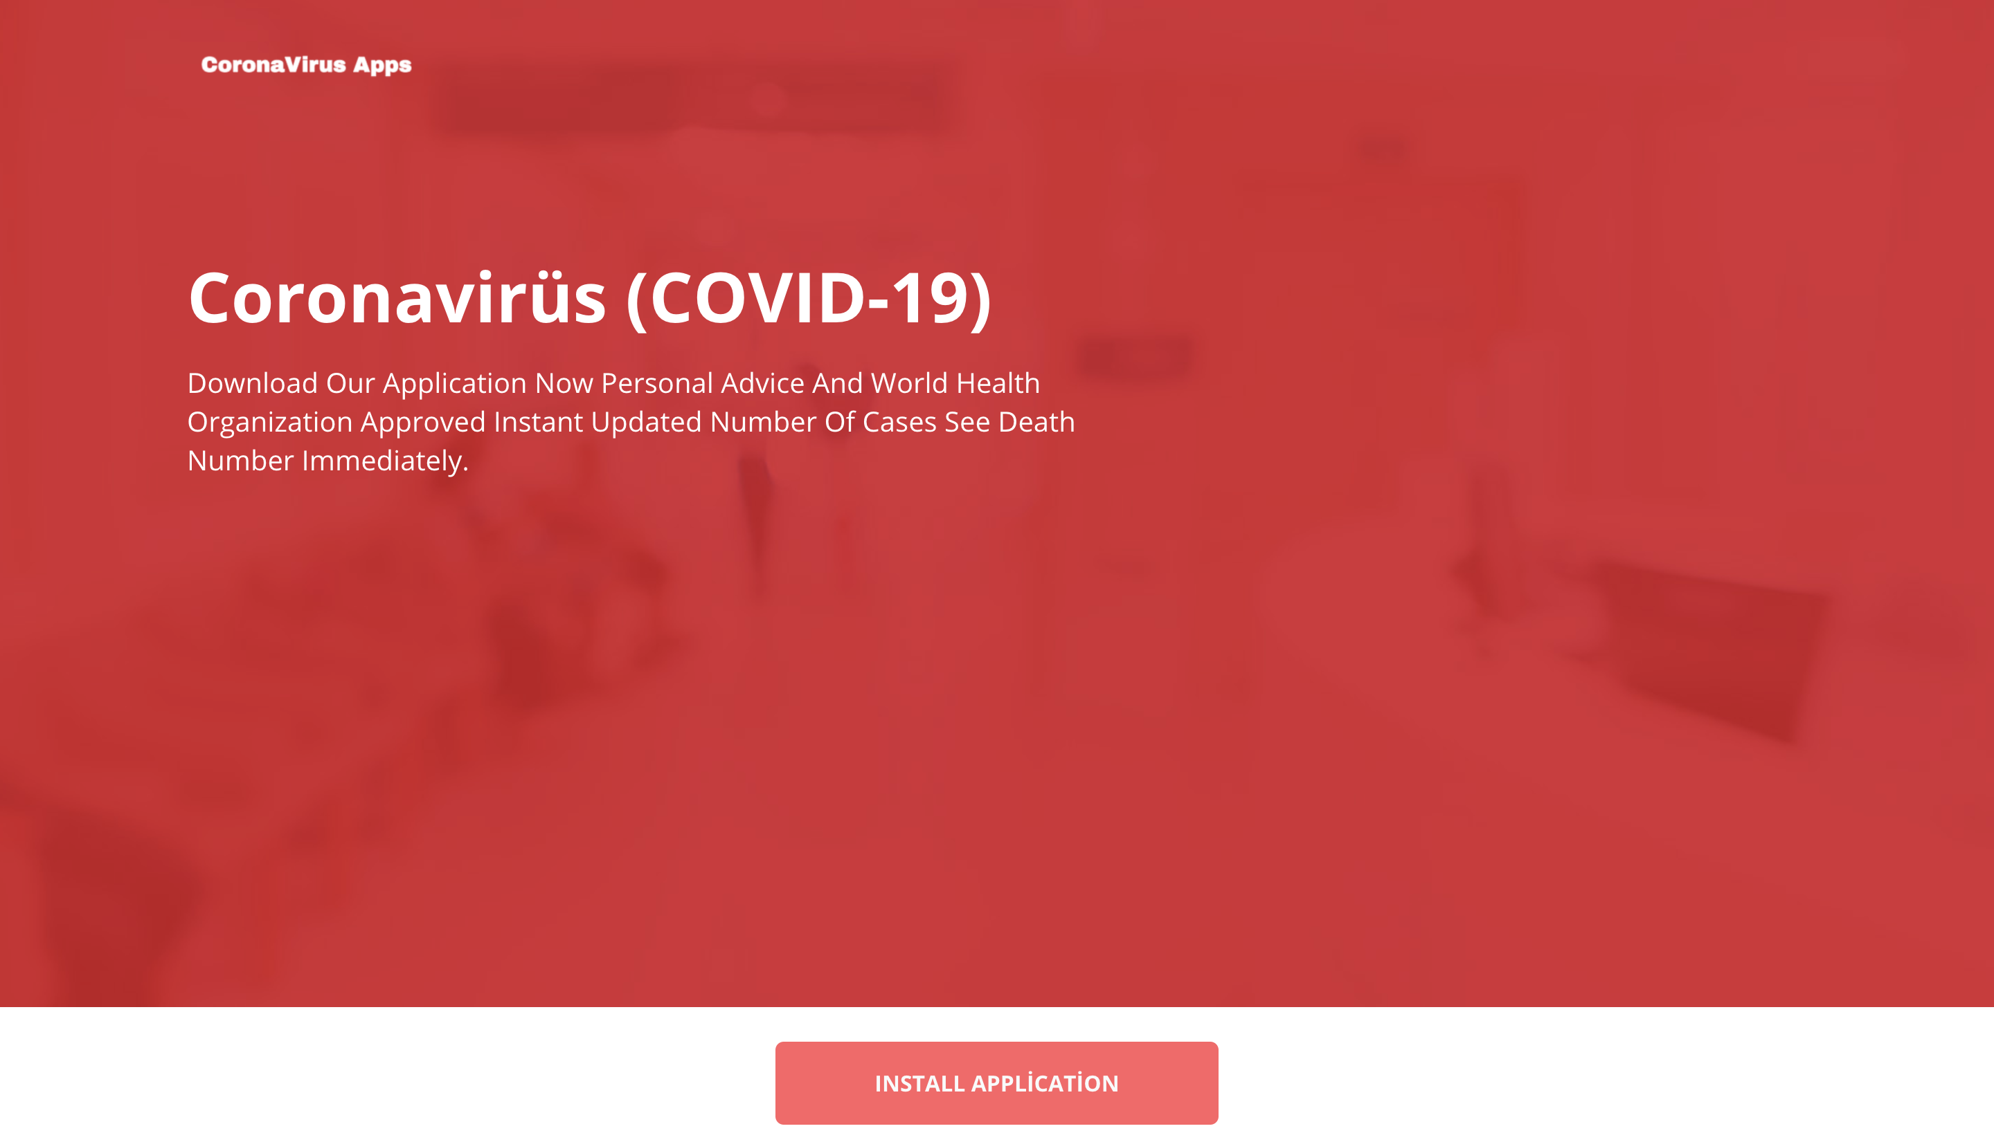~~

Sha256: bca52647ce9f4900b754fcc0d8ef6329fb0229401e833534905969d10a82d839

Detection Name: AndroidOS_Hqwar.HRXI

Payload:

Detection Name: AndroidOS_CerberusPayload.HRX

Sha256: 4637642CBF9FF031A06B9C1FA44D8F812830D51E7AA569A7ACAB6BF4AF6B0298